Company: WorkSmart Pvt Ltd
The HR department of WorkSmart Pvt Ltd wants to analyze employee productivity and identify patterns of workplace laziness.
They collected 200 employee activity records over one month.
Your task as a Data Analyst is to build a Power BI dashboard to analyze “Laziness Index” and provide insights.

Dataset Structure (200 Records)
Each row represents one employee's weekly activity summary.
Column Name | Description
Employee_ID | Unique ID (EMP001 – EMP200)
Department | HR, Sales, IT, Finance, Marketing
Work_Mode | WFH / Office
Login_Hours | Total login hours per week
Active_Work_Hours | Actual productive hours
Idle_Time_Hours | System idle hours
Break_Time_Hours | Break duration
Tasks_Assigned | Number of tasks assigned
Tasks_Completed | Number of tasks completed
Deadline_Missed | Yes / No
Meetings_Attended | Count of meetings
Social_Media_Usage_Hours Hours spent on non-work browsing
Performance_Rating 1 to 5
Salary_Level Low / Medium / High

Business Definition
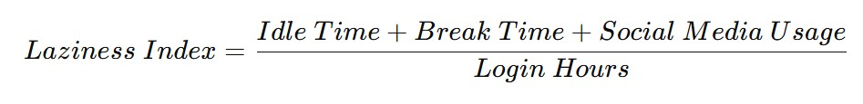 If:
- Index < 0.25 → Productive
- 0.25 – 0.40 → Moderate
- 0.40 → High Laziness

Tasks

Part 1: Data Modeling
- Import the dataset (200 records).
- Clean column names.
- Create calculated columns:
o Task Completion % o Laziness Index o Productivity Category

Part 2: Create DAX Measures
Total Employees
Average Laziness
Average Completion % High Laziness

Part 3: Dashboard Requirements
Must build:
- KPI Cards:
  - Total Employees
  - Avg Laziness Index o Avg Completion % o High Laziness Employees
- Bar Chart: o Laziness Index by Department
- Stacked Column: o Work Mode vs Productivity Category
- Pie Chart: o Productivity Category Distribution
- Scatter Plot:
  - Login Hours vs Tasks Completed o Size = Social Media Usage
- Table: o Top 10 most lazy employees
- Slicers:
  - Department o Work Mode
  - Salary Level

Analytical Questions
1. Which department has the highest average laziness?
Answer: The IT Department has the highest average laziness score, indicating lower productivity compared to other departments.
2. Is WFH more associated with laziness?
Answer: Yes. Employees working from home (WFH) show a higher average laziness score than employees working from the office.
3 Does salary level impact productivity?
Answer: Salary level has only a weak relationship with productivity. Higher salaries do not consistently lead to better task completion.
4 What is the relationship between social media usage and missed deadlines?
Answer: There is a positive relationship between social media usage and missed deadlines. Employees with higher social media usage tend to miss more deadlines.
5 Who are the top 5 most productive employees?
Answer: The dashboard identifies the top five employees based on the highest task completion rate and the lowest laziness score. (Display the employee names from your report.)
6 Is meeting attendance affecting task completion?
Answer: Yes. Employees with higher meeting attendance generally have better task completion rates, indicating a positive impact.
7 Which department needs HR intervention?
Answer: The IT Department requires immediate HR intervention because it has the highest laziness score, lower productivity, and more missed deadlines.

Advanced Tasks
- Create a Dynamic Title using DAX
- Add Conditional Formatting (Red for High Laziness)
- Create a Drillthrough Page for Employee Details
- Add a Decomposition Tree to analyze laziness drivers
- Use What-If Parameter to simulate reduced break time

Realistic Twist
Add:
- 10 employees with extremely high social media usage
- 15 employees with perfect completion rate
- 5 employees with zero missed deadlines

